**SOMAIYA** 

**V I D Y A V I H A R**



**K J Somaiya Institute of Technology**

**An Autonomous Institute Permanently Affiliated to the University of Mumbai**

**DEPARTMENT OF INFORMATION TECHNOLOGY**

**Course Name and Code:** Data Structures Lab **(**ITL302)

**Semester:** III (SYIT)

**Academic Year:** 2024-25 (Odd Semester)

**Experiment No. 09**

**Aim:** Implementation of Binary Search Technique for rea1-world application.

**Code :**

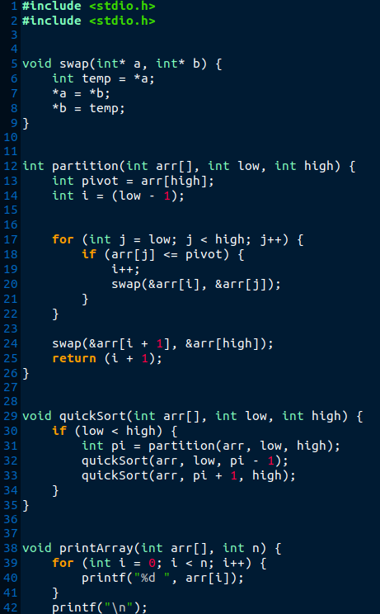

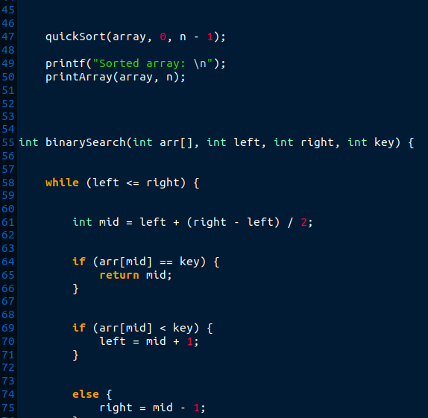

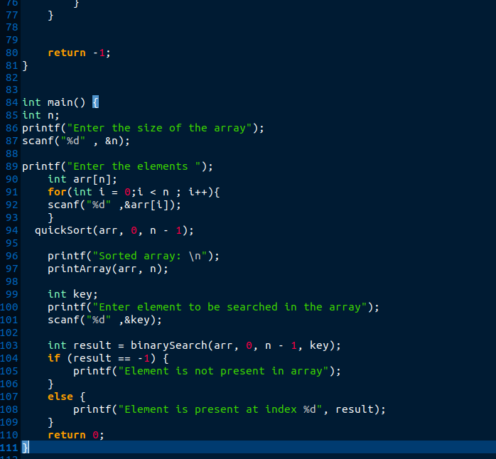

**OUTPUT :**

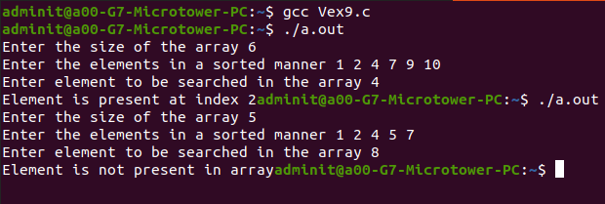

**SUBMITTER DETAILS**

**Name : Veer Gokani**

**Roll No : 30**

**Div : S2/A**

**Date of Submission : 04/10/2024**